**Report on Design Thinking Project**

Subject : Technology and Information Systems (SECP 1513)

Section : 01

Name of Lecturer : Dr Azurah A Samah

Date : 29/11/2023

Title of Design Thinking Product : DirecTranslate

Video Link (youtube): <https://youtu.be/VKBdhymcaLQ?feature=shared>

Link of e-portfolio : <https://github.com/Mlrn206/EPORT> (MELODY)

<https://github.com/AziidanNg/EPortfolio-TIS> (AZIIDAN)

<https://ahmadziq.github.io/Portfolio/> (RAZIQ)

<https://github.com/zafrilll/eportfolio.git> (ZAFRIL)

<https://github.com/aniqaziq/Portfolio-SECP1513.git> (ANIQ)

## Group Profile

|  |  |  |
| --- | --- | --- |
| Name: Melody Lui Ruo Ning  Matric Number: A23CS0244  E-mail: lmelody206@gmail.com  Phone number: 0175411954  Course SECRH | Name: Muhammad Aziidan Bin Muhd Azlan Ng  Matric Number: A23CS0124  E-mail: aziidanng@gmail.com  Phone number: 014-6611044  Course: SECRH | Name: Muhammad Zafril Ihsan Bin Mohamad Nasir  Matric Number: A23CS0304  E-mail:  Phone number:013-8901608  Course: SECBH |
| Name: Muhammad Aniq Aziq Bin Azme  Matric Number: A23CS0122  E-mail: aniqaziq17@gmail.com  Phone number: 013-5821906  Course: SECRH | Name: Ahmad Raziq Bin Ahmad Raif  Matric Number: A23CS0037  E-mail: ahmad29704@gmail.com  Phone number: 01172277491  Course: SECRH |

Comments by Grader:

**Table of Content**

|  |  |  |
| --- | --- | --- |
| Topic | | Page Number |
| Introduction………………………………………………………………… | | 3 |
| Detailed Step……………………………………………………………….. | | 4 |
| Detailed Description……………………………………………………. | | 7 |
| Assessment Point………………………………………………………… | | 8 |
| Evidence……………………………………………………………………… | | 9 |
| Reflections…………………………………………………………………… | | 14 |
|  |

**Introduction**

Design thinking is a process to understand user needs, define user problems, and develop assumptions in order to generate creative solutions for the prototype and testing. Additionally, there are five stages to the design thinking process which are Define, Ideate, Prototype, Test, and Empathize.

Over the past few decades, the design thinking process has grown in popularity because it is recognized as a crucial aspect of successful organizations and businesses. It encourages people to think creatively instead of just simply following to instructions. Design thinking is more than just a process, it provides a new path way to think and create a new solution with the new mindset.

This chapter on system analysis and design has taught us that some types of new system implementation require a system development life cycle. System analysis and design is a six-phase problem-solving steps for examining and improving an information system. This includes investigation, system analysis, system design, system development, system implementation and system maintenance. We use this idea into our project, particularly in situations where we encounter unexpected challenges to effectively address the issues.

Following the design thinking process, we made the decision to create an app for direct translate any languages that would assist users in resolving issues that arise when it comes to communication and traveling issues.

**Detailed Step**

**Empathize**  
We had conducted interview to the person who love travel especially youngsters. Throughout this, we find out the problem that they face during travel. Most of them said that language barrier is the main factor. It is because not all people are fluent in the language of the places they visit. From what we get from interview, we get to know why most of them need the apps that can operate smoothly. As the result, we have come out with some idea about apps can direct translate any languages that users want.

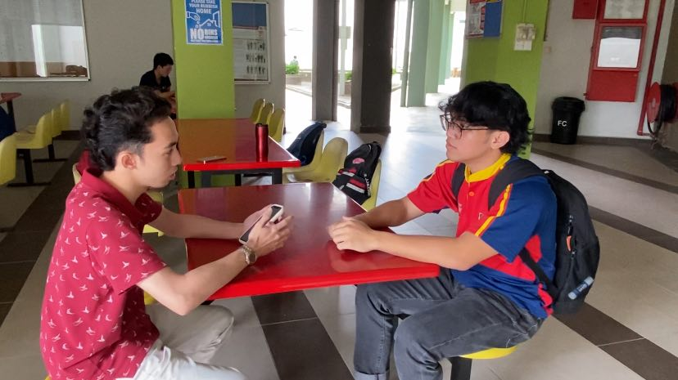

*Diagram 1 : Face-to-face interview with student.*

**Define**  
After the empathized process, we figured out the problem from different aspects. Most of them encountered that app produced an inaccurate translation especially when it comes to complex phrases and sentences. Then, the app also delayed when translating process begin.

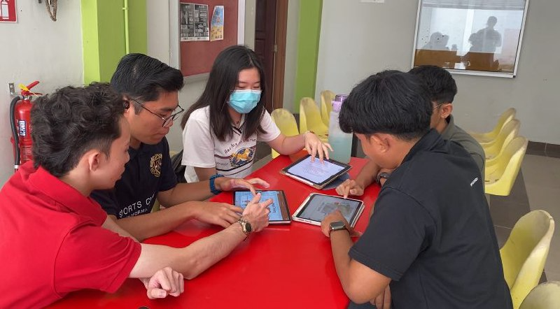

*Diagram 2 : Gathering all the findings after emphasized phase*

**Ideate**  
From the problem that we stated, we started to find solution by brainstorming. We tried as best as we can to find the way to solve this problem for users. Next, we shortlisting the best answer to solve this problem and come out with the best prototype for users. The solution is we enhance the translator software by adding additional libraries, which will enable to translate with more accuracy for complex phrases and sentences.

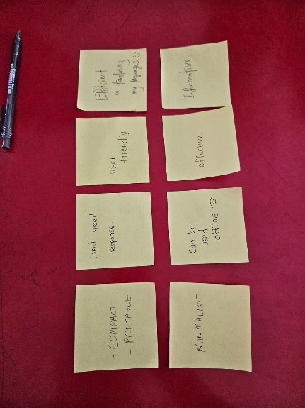

*Diagram 3 : Key words for solution the problem*  
  
**Prototype**  
We came out with prototype by design an app for people who love to travels. We created a prototype names DirecTranslate which have features that make users experience easier. In our prototype, we suggest users to use earbuds or earphone for smooth operation. It will increase the efficiency of this app to operate. This app will directly translate while conversation is ongoing. In addition, these prototypes can be use as reference by people who want learn various languages.  
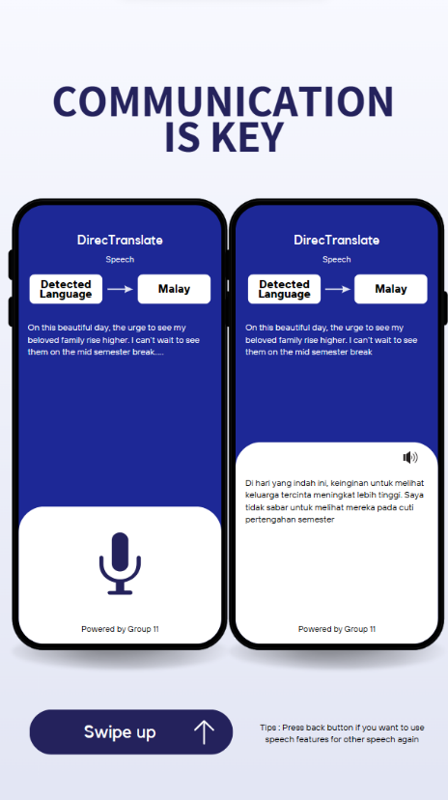 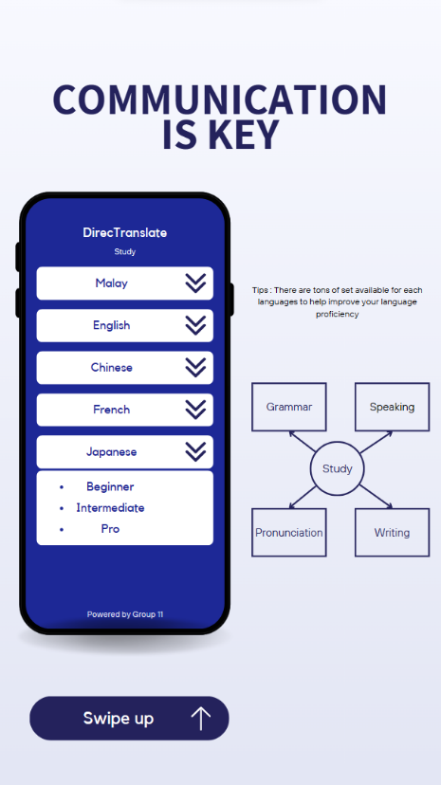 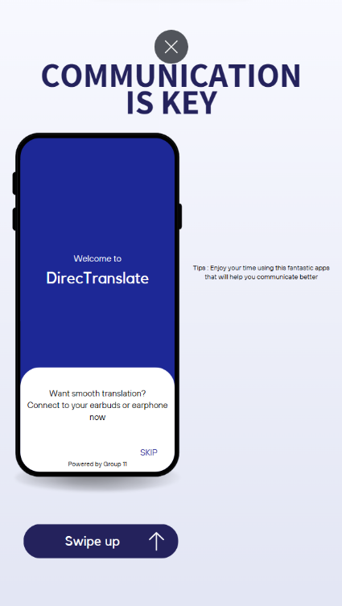

*Diagram 4 : Interface and features on our prototype*

**Detailed Description**

There are a lot of problems that we have discussed, but we agreed on one that is communication. We faced difficulty when trying to communicate with someone who has a different mother tongue. As of today, there are 7106 living languages, and if we focus on a smaller scale, Malaysia has at least 130 different languages. Malaysians mainly speak Malay, English, Mandarin, and Tamil. This mainly because it is a multi-racial country.

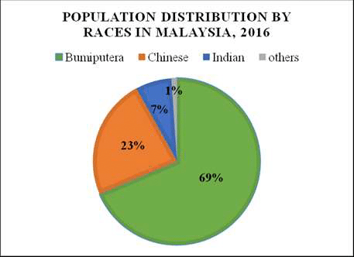

Diagram I : Population Distribution

Part of the difficulty in communication is that most of the population speaks a language that is synonymous with their race as their daily language. They always find it difficult to have an effective conversation when talking with someone from a different country or race. As a long-term solution, one learns the languages by attending classes, but as stated, there are too many languages to be learn.

After stating all the problems, we brainstorm together to find the best way to solve the problems faced in communication. Since we have large targets, we prefer making a mobile application or a website that includes translating and giving recommendations for responses. This is because with automatic recommendations for responses, we can have an uninterrupted conversation that will not be awkward. After a thorough analysis of possible problems and solutions, we decided to create a mobile application that will be constantly updated with more information to create a better and more suitable response for many different languages.

While working in a group, all the group members will have their own point of view but all of us are willing to spend time hearing and contributing with more defined ideas. This led us to a conclusion about the product that satisfied all. Other than that, all of us seem to be quite busy with our own studies, and we rarely get to sit together for discussion, but we successfully distributed all the tasks. This is to ensure there are no free riders in the group. Our high spirit to complete this task makes this project easy and fast to complete.

**Assessment Point**

4.a)

|  |  |
| --- | --- |
| Empathize | Our use of design thinking showcased a commitment to understanding user needs and devising creative solutions. We conducted in-depth interviews with our target group which are youth, students, and travellers. We identified real issues, particularly language barriers during travel. Moving to the define step, we translated our insights into a precise problem description, considering diverse perspectives for a thorough analysis. |
| Define | We translated our insights into a precise problem description, considering diverse perspectives for a thorough analysis. |
| Ideation | We demonstrated creativity and teamwork, brainstorming solutions with active participation from team members. We assessed options and decided on enhancing the translator program by adding more libraries. This analytical problem-solving approach continued through the phase. |
| Prototype | Ideas materialized into a language translation appfeaturing improved translation software aligned with identified issues. Our presentation delved into cultural and linguistic challenges, emphasizing the app's relevance in a world with 7106 languages. The justification was strengthened by realizing the impact of the modern lifestyle on effective communication. |

4.b)   
We employed a methodical and strategic problem-solving approach, evident in our transition from the Empathize to Define phase. Through user interviews, we precisely defined problems, showcasing a deep understanding of user experiences, especially for students and young travelers facing language barriers. This transition demonstrated our skill in breaking down complex problems into manageable statements, laying a strong foundation for the Ideate stage.

Moving from Define to Ideate, we effectively identified issues like inaccurate translations and processing delays, fostering an environment for creative brainstorming. During Ideate to Prototype, our inventive solutions addressed translation accuracy, leading to a prompt decision to expand the translator program's libraries.

The project evolved naturally from ideation to prototype, focusing on implementing innovative concepts. Transitioning to the Detailed Description phase, we enhanced our understanding of communication challenges in a multiracial and multilingual context, emphasizing the importance in Malaysia. Our collaborative spirit persisted, managing differing viewpoints and creating an atmosphere where each contributed to a defined product conclusion.

**Evidence**

**SAMPLE WORK**

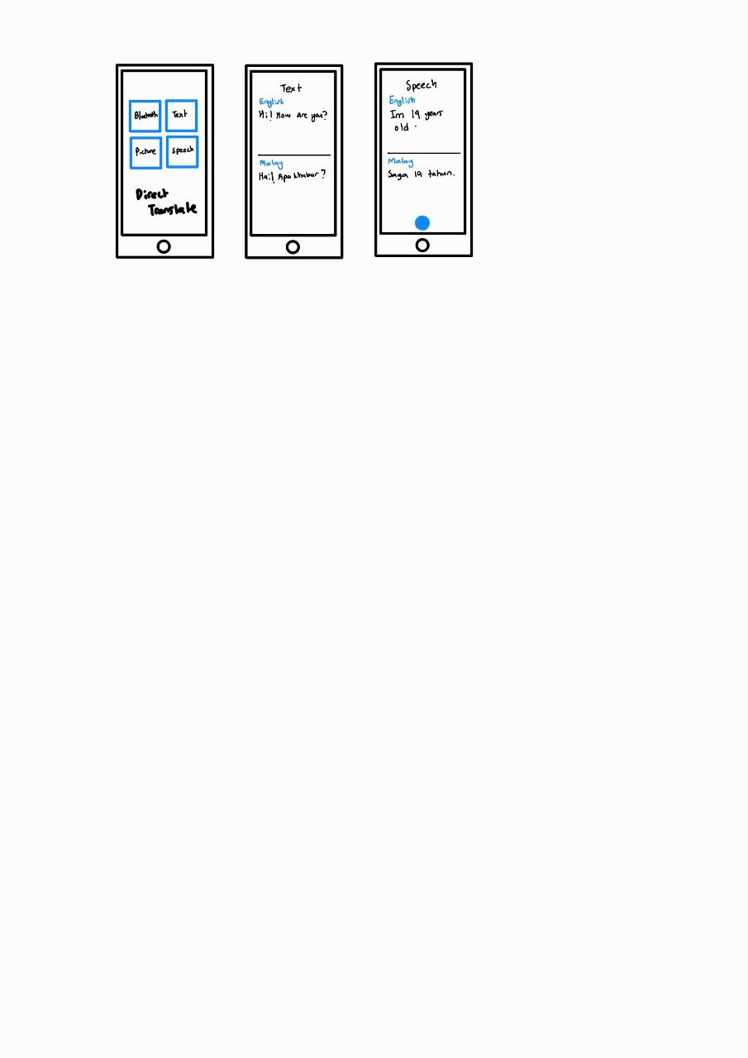

*Diagram 0: Sample sketch prototype*

Diagram 0 above shows the sample sketch for the prototype which include features like Text translate and speech translate.

**EMPATHY**

You may wonder what is empathy means to us. It is actually referring to ability to understand the problem that are facing by end-user. At the same time, we need to put our shoes in end-users’ way of thinking in order to empathize the situation. Besides, observation is important as we can understand their feelings through their body language or facial expressions.

Nowadays, communication with foreigner still causes troublesome among people who are not good at other languages. So, we need to figure it out the problems. To know it in details, we had an interview with a student.

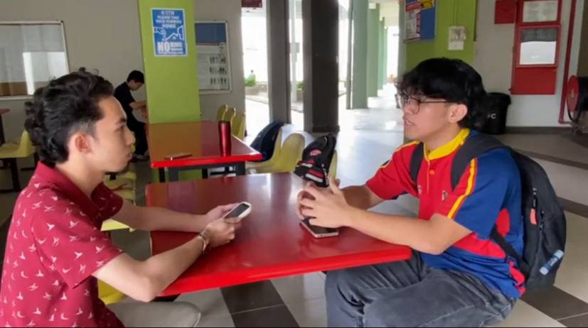

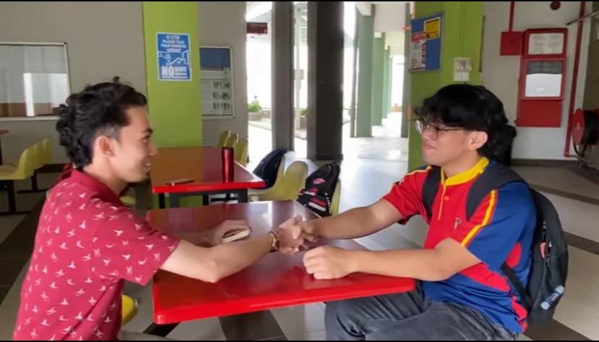

*Diagram 1&2: Interview a student from faculty computing (19 years old) who has communication problem with foreigner.*

**DEFINE**

In this stage, we should list out all of the problems that we are facing during designing the app.

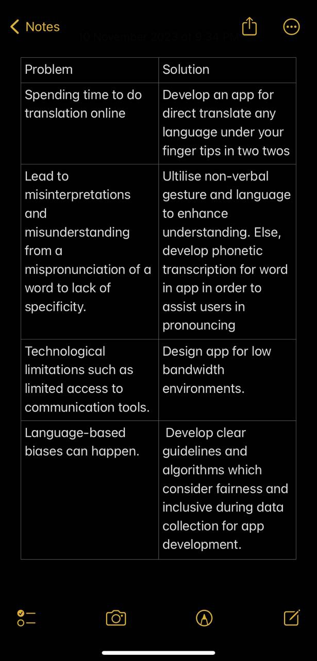

*Diagram 3 : List out the problems and solutions after discussion.*

**IDEATE**

In this stage, we require to spark off ideas in the form of questions and solutions through creative and curious activities such as brainstorm. The goal is to generate large number of ideas that are potentially involve innovation and revolutionary in order to bring the practical and innovative ones to the end-users. For example, we wrote down all of the ideas on the memo. Then, we refine and come out with a final solution through group discussion. This process allows every member to have an equal say in choosing from the listed ideas.

Next, we eventually settled upon an approach. We would redesign and come up with a totally new platform that supersede all the existing features of other apps. Moreover, we trusted that the new interface that we had created would be more operated easily and handy. Lastly, this app will be applicable and remarkable to people.

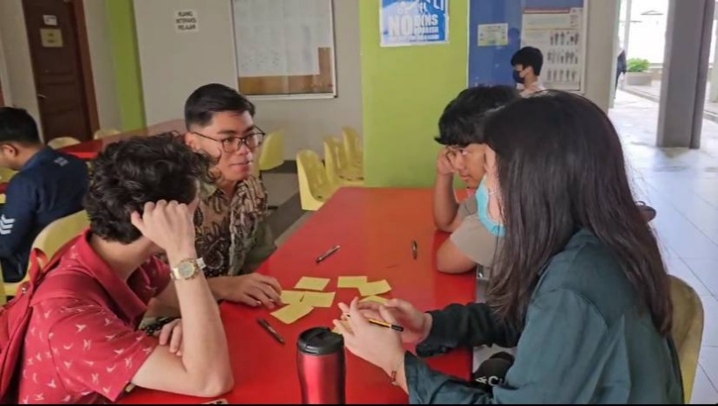

*Diagram 4 : Gathering all the idea and solution after brainstorming*

**PROTOTYPE**

In this stage, we made an user interface using Canva. We use a phone to show our interface as it is a mobile application.

*Diagram 5 : Prototype User Interface Design using Canva*

**TESTING**

After completing the prototype, we did some internal testing and we all satisfied with the prototype.

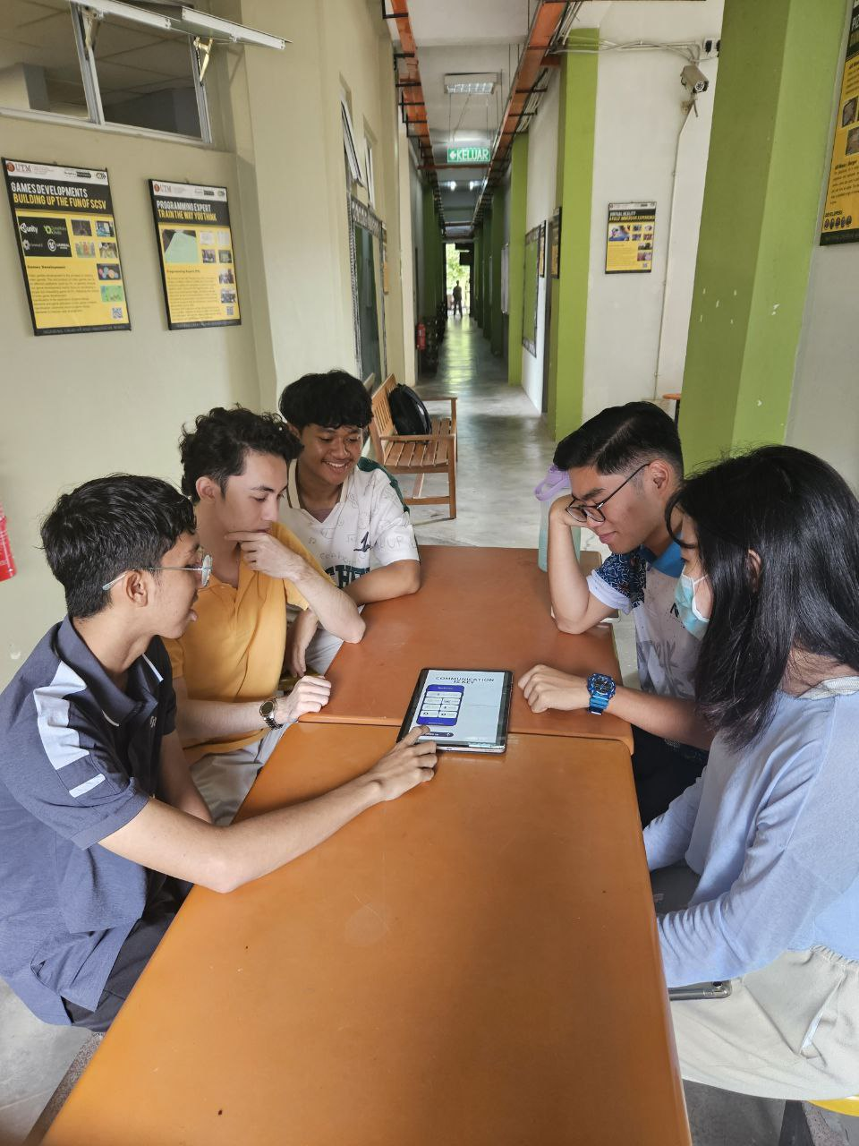

*Diagram 6 : Prototype testing session*

**REFLECTIONS**

By **Melody**

My main goal is to become a successful cybersecurity analyst in the future. I hope that I can advance expertise in specialized areas within cybersecurity such as network security. Moreover, keeping up to date with the latest trends and skills are crucial in order to make contribution to innovation. Furthermore, design thinking impacts my goal from the perspective of iterative. It is due to design thinking allows for the continual refinement of security measures and adapting to emerging threats. By utilizing design thinking, I realised that this is the best way to provide solutions based on real life problems given. This further strengthen my goal to do contribution to the people needed. Lastly, I believe that by improving my technology skills, I will prove my potential and self-value in the industry.

By **Aziidan**

Based on my course which is Computer Network and Security, my main objective is to become a successful cybersecurity expert in the future. I want to become a great expert in the area of computer networks and security so that I can contribute to ground-breaking innovation to help society. I look forward to contributing to data safety and helping companies feel at ease about their clients and server safety. Other than that, design thinking helps me step forward towards achieving my goal. I can see how design thinking really does help me as this is the best way to help me solve a problem meticulously and achieve the best solution for the problem. This further strengthens my goal that I can contribute to the people and society. Lastly, I should have fun exploring all the new technologies so that I am up to date on the latest technology trends. I also need to enhance my skills in IoT, cloud computing, data security, and server safety. I believe if I can keep improving my abilities and knowledge, I will prove my worth and potential in the industry.

By **Raziq**

My long- life dream is to become a cybersecurity specialist. By becoming a cybersecurity specialist, I intend to create a better world where everybody doesn’t need to worry about their security. After learning design thinking, it sparks many ideas to me and taught me many things. Design thinking helps me get closer to my dream. This is due to the fact that design thinking shows me a way to create solutions and solve problems in way you cannot imagine. This skill is really crucial when it comes to being a cybersecurity specialist because you need to anticipate the attacks before they come. Moreover, I still need to improve my skills in technologies and security by learning more about IoT, cloud computing and data security. I believe these skills can help me contribute to society and make a better world where everyone is safe from hackers and scammers

By **Aniq**

My target for my career is to become cybersecurity specialist. I have to keep up with the latest advancements in computer science technologies. In doing so, it will benefit me while pursuing this course. Cybersecurity gives benefits to the community especially their personal data save from hackers or when the cyberattack happen. Based on this, I personally get this opportunity for my personal and professional growth. Furthermore, it impacts my collaboration and communication skills with my team members. This skill will help me a lot in future when I have task that require a team to finish it. In addition, it also improves my problem-solving skills because this assignment required me to provide solutions for the challenges that customers encounter. It is crucial for me to hone my ability to make innovation to the existing product. I should improve my knowledge in IoT and cloud computing which is widely used nowadays. It will increase my potential to compete in the field of computer science with others.

By **Zafril**  
  
Based on my course computer science (bioinformatics), my goal is to apply innovative solutions for advancing biological understanding and healthcare breakthroughs. Design thinking is crucial for its human-centric methodology, prompting me to empathize with end-users and iteratively refine solutions. To improve my potential, I'll focus on continuous learning, staying updated on technological advancements, and collaborating with interdisciplinary teams. Embracing design thinking principles will be crucial in shaping impactful contributions to the dynamic field of bioinformatics.